Functional Specification for
Common Web UI,
Oracle Collaboration Suite, Release 2
Project ID: 8155
Version: 11/30/2002
Status: Review Draft
Author: Lucy Liu
Project Manager: Qiming Huang

Change Log
Version | Reviewers | Changes
11/18/2002 |  | Initial version.
11/19/2002 | attila.bodis | Review comments added.
11/20/2002 | lucy.liu | Review draft complete.
11/21/2002 | Mark Paterson | Integrate Calendar Portlet functionalities and UI design
11/26/2002 | Common Web UI Review Meeting (members from files, calendar, mail, imeeting) | - Add top-level application switcher in corporate branding area.  - Change Preference page layout and action flow  - Make Page header style configurable (thin, medium, and thick styles)  - Resize Company Logo
Review and Approval
The reviewers should have the technical knowledge and authority to state that the project is doing the right thing. If they do not have the authority and knowledge to do this, then they should not be on a review team. (This restriction is for formal technical reviews that determine acceptance. The author is always free to call for informal peer reviews to obtain guidance without approval.) Recommended reviewers are specified by the Product Manager.
If there are external interfaces (anything in section 4 of this document) there should be at least one approver who will review the spec for manageability issues.
A formal technical review ends with accepting or not accepting the reviewed product. The review team accepts the document when they believe it is right. Right means the product has selected the correct alternatives, is complete, and is worth doing (satisfies requirements). Update the title page "Status" line to <Approved> when all issues are resolved and the document is ready for source control.

Table of Contents
1. Project Overview 4
2. Concepts 5
2.1. Patentable Concepts 5
3. Requirements 6
3.1. Functionality 9
3.2. Performance 10
3.2.1. Performance Attributes 10
3.2.2. Performance Tuning 10
3.2.3. Who Should Tune 10
3.2.4. Performance Measurement 10
3.2.5. Administrative Interfaces 10
3.2.6. Configuration Parameters 10
3.3. Availability 10
3.4. Scalability 11
3.5. System/Database Management 11
3.6. Design Constraints 11
3.7. Manageability 11
3.7.1. Database Configuration 11
3.7.2. Performance Tuning 11
3.7.3. Resource Management 11
3.7.4. Administration Tasks 11
3.8. Reliability 11
3.9. Portability and Platform-Specific Requirements 11
3.10. Maintainability 11
3.11. Security 11
3.12. Compatibility 12
3.12.1. Internet Computing 12
3.12.2. Distribution/Replication 12
3.12.3. Internationalization 12
3.13. Diagnosability 12
4. Client Interfaces 13
4.1. Query Statements 13
4.2. Command-line Tools 13
4.3. Initialization Parameter File “init.ora” Parameters 13
4.4. PL/SQL Packages 13
4.5. GUI Design Elements 13
4.5.1. Overview 13
4.5.2. Application Pages 14
4.5.3. Preferences 23
4.5.4. Alternative Preference Page UI 27
4.5.5. Welcome Page 28
4.5.6. Help 29
4.5.7. Portal Home Page 35
4.5.8. Portlets 39
4.6. APIs/Classes 46
4.7. Configuration Files 46
4.8. Other User Interfaces 46
5. Installation and First Use 47
6. Dependencies and Effects 48
6.1. Software 48
6.2. User Documentation 48
6.3. Internal Documentation 48
Compatibility & Migration 49

Project Overview
Oracle Collaboration Suite is an integrated suite of enterprise personal information management (PIM) products. Release 2 of Oracle Collaboration Suite integrates the following products: Oracle Unified Messaging (Email, Voicemail, and Fax), Oracle Calendar, Oracle Files, Oracle iMeeting, and Oracle UltraSearch.
In order to provide a higher level of integration among the above products, Release 2 of Oracle Collaboration Suite provides a number of shared, “cross-product” features such as an integrated portal home page, a consistent web UI look-and-feel, and federated search for contents across all products.
This specification provides product teams with standards and guidance in implementing a common web UI look-and-feel for Collaboration Suite Release 2.

Concepts
Terms and concepts frequently referred to in this functional specification document are defined as follows:
BLAF -- BLAF stands for the Browser Look and Feel which is a set of user interface (UI) guidelines to help designers, developers and product teams build HTML applications. The purpose of the guidelines is to provide a consistent look and feel, consistent interaction model, and ultimately a consistent user experience across the entire suite of Oracle products.
Portlet -- A portlet is an area of HTML/XML located within a defined area of a Web page. Portlets communicate with the portal through an entity called a provider. Portlets form the fundamental building blocks of a Oracle9iAS Portal page. Each portal page consists of content presented through one or more portlets and links that allow the user to navigate to another page to take some action.
JPDK -- JPDK is a set of Java-based Portal Developer Kit which simplifies exposing Java portlets as a Web Provider by providing a set of services that enable Java programmers to easily create portlets from existing J2EE-based applications (Java, Java Servlets, and JSPs). It provides an abstraction to handle communication with Oracle9iAS Portal, default classes to simplify portlet creation, and exposes APIs for end-user customization, session storage, security, and logging.
UIX -- UIX stands for User Interface XML. UIX is also an extensible, J2EE-based framework for building web applications. The names such as "Cabo," "Baja," and "Marlin" are often used as part of UIX technology stack. By default, UIX Components implements the View or presentation layer as HTML that conforms to Oracle BLAF (Browser Look and Feel).
OHW -- Oracle Help for the Web (OHW) is an HTML-based version of Oracle Help. OHW uses UIX framework to create its web UI. OHW can be part of your web application through a global help button with a link to your instance of the OHW servlet. OHW will also provide a means of providing context sensitive help.
Data Binding – For the pages implemented in UIX based on the Model-View-Controller (MVC) design pattern can use dynamic data binding mechanism to render the same page view with different data contents that are dynamically bound to the page.
Accessibility -- Successful access to information by people with disabilities is known as "accessibility". OAC (Oracle Accessibility Checker) is an Oracle internal web site which provides tools to check that your web pages are coded to meet the standards of Section 508 of the Federal Rehabilitation Act. Usually, we will also use JAWS screen reader to verify the HTML pages can be properly read for the visual disabled people.
Globalization – All the labels in a web page need to be translated into different languages that are going to be supported in Oracle Collaboration Suite.

Patentable Concepts
There are no patentable concepts in the scope of this specification.

Requirements
Following are the requirements that we received from the Product Management team regarding the Common Web UI of Oracle Collaboration Suite: (Reference: PRD_Common_WebUI_111702.doc)
- Customizable Collaboration Suite Portal Page (Required)
- Navigation Between Applications (Required)
- Email Portlet (Highly Desirable)
- Calendar Portlet (Highly Desirable)
- Files Portlet (Highly Desirable)
- iMeeting Portlet (Highly Desirable)
- Search Portlet (Required)
- SMS Portlet (Required)
- Favorites Portlet (Required)
- Common Address Book Application (Required)
- Wireless &Voice Preference Enhancement (Required)
- Select Multiple Mobile Inbox Views (Highly Desirable)
- Customized Mobile Inbox Views (Desirable)
- Common Online Help (Desirable)
- Common Preferences (Desirable)

Details as follows:
- Customizable Collaboration Suite Portal Page (Required):
  - Collaborative Portlets
The Oracle Collaboration Suite front page should be implemented using Oracle Portal.
  - Display Critical Collaboration Information
“Critical information” is defined as Time/Context Based, Priority Based, and Interest Based information. All of these parameters might have some default values at the system level, but they should be customizable by the end user.
  - Enable Critical & Simple Interaction
For Simple and Critical action, the user should be able to interact with the Portal with switching to a specific application.
  - Link every information item to the appropriate application
For example, from the portal page, clicking on a calendar event will switch to the calendar application for the full application.
- Navigation Between Applications (Required):
  - User should be able to switch between applications without using browser back button or without going back to Collaboration Suite main portal page.
  - When the user switch between applications, the previous application should keep its context, allowing the user to continue exactly where he was if switches back to previous application.
- Email Portlet (Highly Desirable):
  - By default, Email portlet should display the summary of the Inbox (Number of New Email messages, Number of new Voice messages, number of new Fax messages.), and the preview of first 5 messages.
  - User should be able to turn on/off the summary, and should be able to configure the preview content to one of the Mobile Inbox View:
    - First x New messages
    - First x New Messages from specified sender(s)
    - First x New Urgent Messages
    - First x New Voicemail messages only
    - First x New Fax messages only
Note: By default x should be set to 5. x should also be made configurable, if display permits.
- Calendar Portlet (Highly Desirable):
(Refernce: Calendar Portlet Design Doc)
  - Provide a mechanism to view today’s events using Oracle Calendar Web Services framework.
  - Upon selection of a calendaring event, the Calendar Web Client will display the “Edit Entry” page for this meeting, allowing the user to edit, delete or take no action. The returning URL will be the Calendar Portlet page with the updated contents.
  - Display some sort of indicator that there are more events than what Calendar Portlet can display at time – i.e. “More…” link can take you to today view of OCWC.
  - Provide support for viewing daily notes, day events and holidays.
  - Support for showing reply status of a particular event via icons – only attending and unconfirmed events are displayed.
  - No use of XSL in this release unless required by Portal framework.
  - Sorting will be based on date/time (in UTC) only for this release. Server’s default TZ.
  - For daily notes, day events and holidays title will be used for sorting key.
  - The mechanism must be fast – data gathering is Web Services dependent but UI generation should be designed such that Portlet display is done in reasonable time.
  - Portlet UI must be ready for globalization – displayable strings and graphics works.
  - Ability to display “No appointments” if there is no appointment in given date range.
- Files Portlet (Highly Desirable):
  - By default, Files portlet should display the top-level workspace hierarchy.
  - User should be able to select the workspaces, and their mode (expanded, collapsed), to include in the portlet.
  - To be consistent, user should NOT be able to search from Files portlet. User should use the Search portlet and select only Files data store to search in files.
- iMeeting Portlet (Highly Desirable):
  - By default, iMeeting portlet should display the summary of the iMeeting scheduled for that day.
  - User should be able to join the iMeeting with one click from the portlet.
  - User should be able to customize to view the public meetings in the portlet.
- Search Portlet (Required):
  - User should be able to perform a simple search from the search portlet.
  - User should be able to select the multiple data sources (Email, Files, Calendar, iMeeting, Web) for the search.
- SMS Portlet (Required):
SMS has become the most popular communication channel in Europe, and is also taking the rest of the world by storm. OCS already provides functionality to send/receive SMS/MMS messages from the Wireless interface. But we also need to provide the capability to quickly send out SMS message from portal page to recipients selected from Personal Address Book, or corporate directory. We need:
  - Ability to send SMS to a phone number or email address (Highly Desirable)
  - Ability to select the recipient from personal address book (Highly Desirable)
  - Ability to select the recipient from corporate directory. For recipient selected from corporate directory, SMS address and notification delivery rules should be picked up from Presence Server. (Highly Desirable)
  - Should be able to specify/change the return-to SMS address. This field should be pre-populated with the sender’s latest SMS address picked up from Presence Server. (Highly Desirable)
  - Boilerplate to quickly compose SMS messages. Some examples: (Desirable)
    - I am running late by <> minutes
    - I’m on my way
    - Meeting is <cancelled/confirmed/delayed>
    - Thank you for <Lunch/Breakfast/Dinner/the reminder/the meeting>
    - Please call me <on my mobile/at office/at home>
- Common Address Book Application (Required):
  - Collaboration Suite v2 will have a OID based common address book, which will be shared by all components. There should be an application to view and manage this common address book.
  - There should also be a link to go to Common Address Book application from the main portal as well as relevant applications.
- Wireless &Voice Preference :
  - Notification Rules UI (Required)
Currently, OCS has a very inconsistent UI to specify the notification rules. Calendar Notification rules can be specified within the Calendar Web Client, but Mail notification rules can be specified from the Portal page under Wireless & Voice preferences. To be consistent, we should take out all Notification Creation Rules from the Portal page, and move them under respective application web client. However, we should add UI for Notification Delivery Rules (Blackout period, Notification Turn on/off, Maximum number of alerts) under Wireless & Voice preferences.
  - PIN field should display *s (Required)
Once the user has specified the PIN on Wireless & Voice preferences page, PIN field should display fixed number of *s next time instead of blank. User gets confused when he sees PIN field blank, and fill in PIN every time he comes across that page.
  - Default Voice Access Number and Wireless Access URL (Required)
    - Default Voice Access number should be 1-800-###-####.
    - Default Wireless access URL should NOT be http://mobile.marconi.com. Marconi.com is a registered domain name of a Communications company named “Marconi Corporation PLC”. We should either specify a commonly used placeholder URL, if there is such a thing; otherwise, we can specify http://<Wireless Access URL> until the System Administrator sets it up.
- Select Multiple Mobile Inbox Views (Highly Desirable):
  - Mobile Inbox provides user faster, personalized access to critical messages. OCS v1 Web UI provides following 5 pre-set Mobile Inbox filters.
    - List of senders – Only messages from a specified list of senders. User can specify the list of senders from the Portal->Wireless preferences page.
    - Urgent – Messages marked as Urgent or have “urgent” in subject field
    - Today – Messages received in last 24 hours
    - Voicemail – Only Voice Messages
    - Fax – Only Fax Messages
In OCS v1, user can only select one Mobile Inbox Filter at any time. We need to provide ability to select multiple Mobile Inbox Filters.
  - Instead of radio-box, we need to provide check boxes to allow select multiple Mobile Inbox filters.
- Customized Mobile Inbox Views (Desirable):
  - In OCS v1, we only allow user to select from a list of pre-defined Mobile Inbox Filters. We need to provide UI to create complex, customized mobile inbox filters.
  - Unified Messaging Team need to provide APIs to create these customized Inbox views.
- Common Online Help (Desirable):
  - All component applications' help pages should be accessible from a single, global help UI.

Functionality
- Same Look And Feel Across All Web UI in Collaboration Suite
All applications should provide same look and feel web UI by following the guidelines provided in this document.
- Collaboration Suite Portal Home Page
This page will be implemented using portlets with PDK (Portlet Development Kit).
- Email Portlet
Functionality list will be provided by Email team.
- Calendar Portlet (Reference Calendar Portlet Design Doc)
  - Calendar link on top will now contain current viewing date information
  - Event has URL that leads to a particular event in Calendar Web Client for full edit activity.
    - When coming back from Calendar Web Client, update content will be shown in Portlet
  - There is “More…” link available if more than X number of entries are available.
- Files Portlet
Functionality list will be provided by Files team.
- iMeeting Portlet
Functionality list will be provided by iMeeting team.
- Search Portlet
Functionality list will be provided by Search team.
- Desktop Messaging (SMS) Portlet
  - Ability to send SMS to a phone number or email address
  - Ability to select the recipient from personal address book
  - Ability to specify/change the return-to SMS address. This field should be pre-populated with the sender’s latest SMS address picked up from Presence Server.
- Common Address Book Application :
To be completed.
- Favorities :
  - User can navigate to the corresponding detail application page from the favorite links.
  - User can add or delete favorite links in this portlet.
- Wireless &Voice Preference :
  - Notification Rules UI
Add UI for Notification Delivery Rules (Blackout period, Notification Turn on/off, Maximum number of alerts) under Wireless & Voice preferences.
  - PIN field should display *s
Once the user has specified the PIN on Wireless & Voice preferences page, PIN field will display fixed number of *s next time instead of blank.
  - Default Voice Access Number and Wireless Access URL
    - Configurable voice access number.
    - Configurable web access URL.
- Common Online Help :
  - All component applications' help pages should be accessible from a single, global help UI.

Performance
A performance testing strategy will be constructed later to do the performance benchmark against every application. Detail information will be completed later.

Performance Attributes
To be completed.

Performance Tuning
N/A.

Who Should Tune
N/A.

Performance Measurement
To be completed.

Administrative Interfaces
N/A.

Configuration Parameters
N/A.

Availability
One logical application instance may be composed of multiple physical application instances. Meaning that one application can be configured and running on multiple servers. However there is only one single entry URL exposed to the user. In the Common Web UI, this entry URL is used to link to the
application. If any physical instance is down, the application is still available.

Scalability
N/A.

System/Database Management
N/A.

Design Constraints
- All pages must be BLAF-compliant
- All applications should be easily reachable from any other application without going back to the portal home page
- When the user switch between applications, the previous application should keep its context, allowing the user to continue exactly where he/she was if switches back to previous application. If the caching is not possible, a warning message should prompt to the user.
- All applications must participate in SSO

Manageability
To be completed.

Database Configuration
N/A.

Performance Tuning
N/A.

Resource Management
N/A.

Administration Tasks
Please refer to OCSCA (“Oracle Collaboration Suite Configuration Assistant”) functional spec for installation and configuration details. (see project #8160).

Reliability
N/A.

Portability and Platform-Specific Requirements
To be completed.

Maintainability
N/A.

Security
All the web UI pages should be protected by SSO (Single Sign On) authentication server.

Compatibility

Internet Computing
N/A.

Distribution/Replication
N/A.

Internationalization
All the labels in the customer-facing web UI pages should be submitted to the translation team for translating into 26 languages. Please refer to the “Globalization” sections in this document for details.

Diagnosability
N/A.

Client Interfaces

Query Statements
N/A.

Command-line Tools
N/A.

Initialization Parameter File “init.ora” Parameters
N/A.

PL/SQL Packages
N/A.

GUI Design Elements

Overview
To be completed.

Application Pages
All Collaboration Suite application pages must support the following page layout:
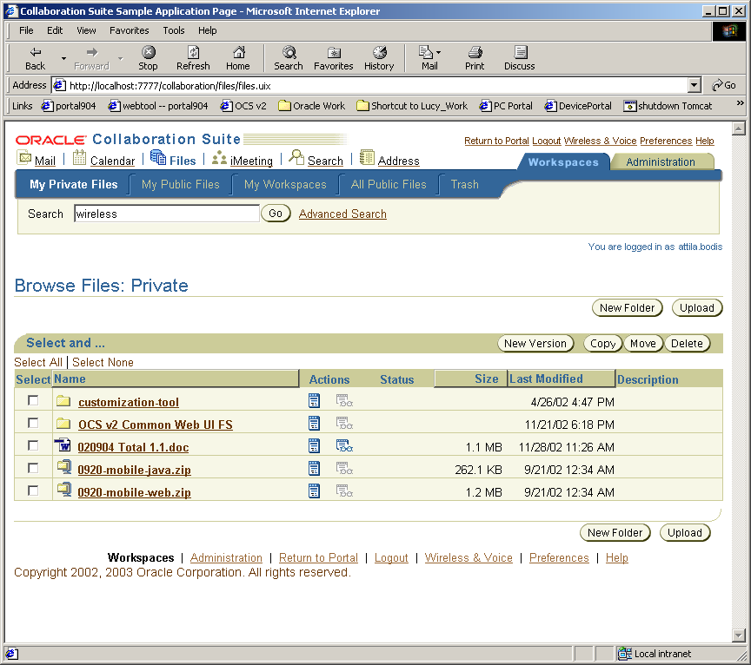
Header
Footer
Each page is made up of a standard page header, the application-specific page body, and a standard page footer.

Header
Global
Links
All Collaboration Suite applications must support the following page header:
Logo
Application Switcher

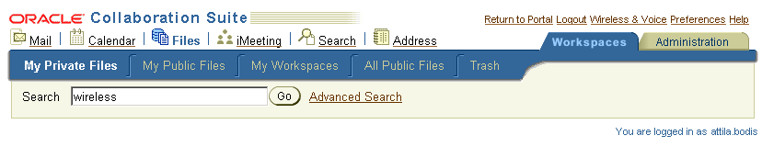
Quick Search
2nd-Level Tabs
1st-Level Tabs
Greeting

The page header is made up of a logo, a application switcher, a global button bar, first-level tabs, optional second-level tabs, a search box, and a greeting.
The header style can be configured into medium and regular branding styles. For the medium branding style, the global buttons will be rendered in links only. And for the regular branding style, the global buttons can be rendered in both icon and text style.
The application switcher can be configured into 3 different styles : icon and text, text only, or icon only.
Following are the 6 different header styles :
(1) Regular branding style + icon and text application switcher
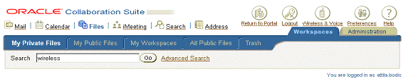
(2) Regular branding style + icon only application switcher
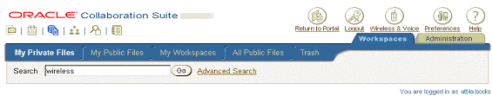
(3) Regular branding style + text only application switcher
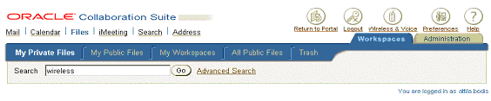
(4) Medium branding style + icon and text application switcher
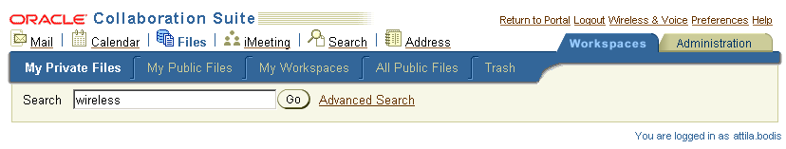
(5) Medium branding style + icon only application switcher
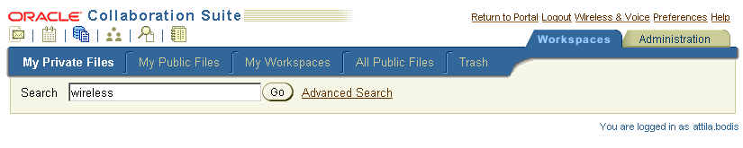
(6) Medium branding style + text only application switcher
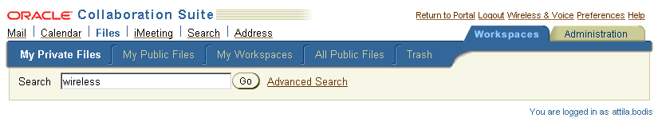

Logo
The logo is a composite of 2 images and one HTML text : a small corporate branding logo, a product name (text), and a collage (lines image).
For the Regular Branding Style :
The corporate logo (oraclelogo_incontext_reg.gif) can be downloaded from Files Online at http://files.oraclecorp.com/content/MyWorkspaces/ST Functional Specs/OCSv2/Common Web UI/Images/oraclelogo_incontext_reg.gif
The product name “Collaboration Suite” is a HTML text using BLAF CSS style, OraHeader .
The lines image (lines_incontext_reg.gif) can be downloaded from Files Online at http://files.oraclecorp.com/content/MyWorkspaces/ST Functional Specs/OCSv2/Common Web UI/Images/lines_incontext_reg.gif
(The images stored on Files Online may be updated; check back periodically for the latest images.)

For the Medium Branding Style :
The corporate logo (oraclelogo_incontext_medsmall.gif) can be downloaded from Files Online at http://files.oraclecorp.com/content/MyWorkspaces/ST Functional Specs/OCSv2/Common Web UI/Images/oraclelogo_incontext_medsmall.gif
The product name “Collaboration Suite” is a HTML text using BLAF CSS style, OraHeaderSub.
The lines image (lines_incontext_medsmall.gif) can be downloaded from Files Online at http://files.oraclecorp.com/content/MyWorkspaces/ST Functional Specs/OCSv2/Common Web UI/Images/lines_incontext_medsmall.gif
(The images stored on Files Online may be updated; check back periodically for the latest images.)

Data Binding
Neither image is clickable; but the labels such as product name and ALT texts need to have data binding.

Accessibility
Images must have ALT text associated with them in order to be correctly processed by screen readers. The ALT text associated with the corporate branding image should be “Oracle logo.” The ALT text associated with the product logo should be “Collaboration Suite logo.”

Globalization
The Oracle logo image does not need to be translated; therefore it is acceptable to hardcode the names of these image files. The ALT text associated with the images should be translated. Also, the product name “Collaboration Suite” and all the application names need to be translated.

Implementation
Pages built using UIX should include the logo via the <corporateBranding> named children of the <pageLayout> element:
<!-- UIX 2.1.9 -->
<pageLayout ...>
...
<corporateBranding>
<flowLayout>
<contents>
<image data:source="..." data:shortDesc="..." .../>
<styledText data:text="..." styleClass="OraHeaderSub”/>
<image data:source="..." data:shortDesc="..." .../>
</contents>
</flowLayout>
</corporateBranding>
...
</pageLayout>

Application Switcher
This image-style application switcher is put in the original product branding area.
As mention in above section that the application switcher rendering style can be configured to 3 different styles : icon and text, icon only or text only.
Each application is composed by an icon image and a application name. The non-selected applications will use inactive icon and clickable name. The applications are separated by a vertical line. For the selected application, the icon will be active image and the name will not be clickable.
The selected name text is using BLAF CSS OraShuttleHeader style defined as :
.OraShuttleHeader,.x36 {
font-family:Arial,Helvetica,Geneva,sans-serif;font-size:92%;color:#336699;font-weight:bold
}

The unselected name text is using BLAF CSS OraInstructionText style defined as :
.OraInstructionText,.xk {
font-family:Arial,Helvetica,Geneva,sans-serif;font-size:x-small;color:#000000
}

The button images can be downloaded from Files Online at http://files.oraclecorp.com/content/MyWorkspaces/ST%20Functional%20Specs/OCSv2/Common%20Web%20UI/Images.
(The images stored on Files Online may be updated; check back periodically for the latest images.)
Applications must maintain context as much as possible by keeping state information in the HTTP session. For example, if a user is browsing the “Drafts” folder in the Mail application, clicks “Files” to go to the Files application, then clicks “Mail” again to go back to Mail, the Mail application should ensure that the user is returned to the “Browse Drafts Folder” screen and not the “Welcome to Mail” screen. If the user is currently in the middle of editing a new mail message, clicks “Files,” then clicks “Mail” again, the Mail application is not required to allow the user to resume editing the message where they left off; it is sufficient to display the Compose Message screen, but with any unsaved changes lost.

Data Binding
The URLs for each application must be retrieved from the global registry if available; any application that has not been configured (and is therefore not found in the global registry) must not have its corresponding application icon or text rendered.

Accessibility
Images must have ALT text associated with them in order to be correctly processed by screen readers. And all application icons and text should be navigated by tab clicking.

Globalization
The ALT text associated with the images should be translated.

Implementation
Pages built using UIX should include the logo via the <productBranding> named children of the <pageLayout> element. Because the image-styled application switcher is not supported in current UIX release (2.1.9), therefore we have created 2 templated to simulate the style and behavior. One is <cs:application>, the other is <cs:applicationSwitcher> and they will be replaced by the real support from CABO team in the later release.
<!-- UIX 2.1.9 -->
<pageLayout ...>
...
<corporateBranding>
<cs:applicationSwitcher data:selectedValue=”selectedValue@dataProvider”>
<contents data:childData="app@appList" >
<cs:application data:text="text"
data:icon="icon"
data:value=”value”
data:href=”href”/>
</contents>
</cs:applicationSwitcher>
</corporateBranding>
</cs:applicationSwitcher>
...
</pageLayout>

Global Buttons
As mention in above section that the render style can be configured to 2 different styles : regular branding style (icon and text), or medium branding style (text only).


The order of the buttons is significant (per BLAF): return-to-portal button, followed by login/logout button, followed by application-specific button(s), followed by preferences, followed by help. The only application-specific button allowed in Collaboration Suite is the “Voice & Wireless” button.
The button images can be downloaded from Files Online at http://files.oraclecorp.com/content/MyWorkspaces/ST%20Functional%20Specs/OCSv2/Common%20Web%20UI/Images.
Semantics are as follows:
- Clicking “Return to Portal” takes the user back to the Collaboration Suite portal home page. The “Return to Portal” button must not be rendered if the Collaboration Suite portal home page is not configured.
- Clicking “Logout” logs the user out of single sign-on (SSO). This button is always present.
- Clicking “Voice & Wireless” takes the user to the voice & wireless setup wizard. The “Voice & Wireless” button must be hidden if the iAS Wireless server is not configured.
- Clicking “Preferences” takes the user to the application-specific preferences page. This button is always present.
- Clicking “Help” takes the user to the application-specific help page. This button is always present.

Data Binding
The “Return to Portal” URL must be retrieved from the global registry if present; otherwise the button must not be rendered.
The “Voice & Wireless” URL must be retrieved from the global registry if present; otherwise the button must not be rendered.
The “Preferences” URL is private to each application and must be handled internally by the application.
The “Help” URL is private to each application and must be handled internally by the application.

Accessibility
Each global button image must have associated ALT text in order to be properly processed by screen readers. The global button bar must be keyboard-navigable.

Globalization
All global button labels and all associated ALT texts must be translated.

Implementation
Pages built using UIX should use the <globalButtonBar> named child of the <globalButtons> element (itself a child of <pageLayout>) to render the global button bar:
For the General Branding Style (rendering both icon and text for the global buttons)
<!-- UIX 2.1.9 -->
<pageLayout>
...
<globalButtons>
<globalButtonBar>
<contents>
<globalButton source="images/returntoportal_greyscale.gif"
data:text="..." data:destination="..."/>
<globalButton source="images/logout_greyscale.gif"
data:text="..." data:destination="..."/>
<globalButton source="images/mobile_greyscale.gif"
data:text="..." data:destination="..."/>
...
</contents>
</globalButtonBar>
</globalButtons>
...
</pageLayout>

For the Medium Branding Style (only rendering text for the global buttons)
<!-- UIX 2.1.9 -->
<pageLayout>
...
<globalButtons>
<globalButtonBar>
<contents>
<globalButton data:text="..." data:destination="..."/>
<globalButton data:text="..." data:destination="..."/>
<globalButton data:text="..." data:destination="..."/>
...
</contents>
</globalButtonBar>
</globalButtons>
...
</pageLayout>

The buttons themselves should be rendered using <globalButton> elements. In order to take advantage of the image generation features of UIX, use the grayscale images in conjunction with the source attribute of <globalButton>.
Button visibility should be controlled by using data binding on the rendered attribute.

Top-Level Navigation
All the top-level navigation is decided by individual application. If the logged in user have the administrator privileges, an “Administration” can be rendered in the first-level navigation tab. The “Administration” tab should always be rendered as the right-most item in the left-to-right sequence.

The tab bar should be generated using UIX image generation; there are no static image files available.
Applications must maintain context as much as possible by keeping state information in the HTTP session.

Data Binding
The URLs for each tab must be provided by each application

Accessibility
All tabs must have associated ALT texts for screen readers. The tab bar must be keyboard-navigable.

Globalization
All tab text (and associated ALT text) must be translated.

Implementation
Pages built using UIX should implement the tab bar using the <tabs> named child of the <pageLayout> element:
<!-- UIX 2.1.9 -->
<pageLayout>
...
<tabs>
<tabBar data:selectedIndex="...">
<contents>
<link data:text="..." data:destination="..."/>
...
</contents>
</tabBar>
</tabs>
...
</pageLayout>

Tab visibility should be controlled by using data binding on the rendered attribute.

Second-, Third-, and Fourth-Level Tabs
Second-, third-, and fourth-level tabs may be used by each application as needed. Each application is responsible for ensuring that second-, third-, and fourth-level tabs are rendered in accordance with BLAF specifications, meet accessibility criteria, and support globalization.

Search
Each application is responsible for providing a search box on all top-level application pages:

The label for the search box must be “Search” and the label for the button must be “Go” (per BLAF).
Applications that support additional controls must clear any additions with the Collaboration Suite product management team and the UI/Usability team. Here is an example of additional controls (from the Files application):
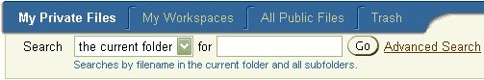
Semantics for search are as follows:
- If an application has its own quick search functionality and search results UI, then clicking “Go” will submit the user’s query to the application’s own search implementation, and the results will be displayed in the application’s own search results page.
- If an application has its own advanced search functionality, then clicking “Advanced Search” will take the user to the application’s own advanced search page.
- If the application does not have any built-in quick search functionality, then clicking “Go” will submit the user’s query to the Collaboration Suite Federated Search application, and the results will be displayed in the Federated Search results page (note that this will switch the user’s application context to the Federated Search application). If Federated Search is not configured, the search box must not be rendered.
- If the application does not have built-in advanced search functionality, then clicking “Advanced Search” will take the user to the Collaboration Suite Federated Search application (note that this will switch the user’s application context to the Federated Search application). If Federated Search is not configured, the search box must not be rendered.

Data Binding
Applications that implement their own quick and/or advanced search must ensure that the search form is submitted to the appropriate handler and that the URL bound to “Advanced Search” is the correct one.
Applications that rely on Federated Search must retrieve both the quick search URL and the advanced search URL from the global registry, if Federated Search is configured; otherwise the search box must not be rendered.

Accessibility
The “Go” button must have an associated ALT text for screen readers. The entire search form must be keyboard-navigable.

Globalization
All labels, links, ALT texts, and hints (if any) must be translated. In addition, queries relying on the Federated Search engine must support NLS text queries; see the Federated Search functional specification for more information.

Implementation
Pages built using UIX should use the <quickSearch> named child of the <pageLayout> element to render the search box:
<!-- UIX 2.1.9 -->
<pageLayout>
...
<quickSearch>
<form name="quicksearch" data:destination="...">
<contents>
<tableLayout cellSpacing="4">
<contents>
<rowLayout vAlign="middle">
<contents>
<messageTextInput data:prompt="..." name="query"/>
<end>
<submitButton data:text="..."
ctrl:event="search"/>
</end>
</messageTextInput>
<spacer height="1" width="1"/>
<link data:text="..." data:destination="..."/>
</contents>
</rowLayout>
</contents>
</tableLayout>
</contents>
</form>
</quickSearch>
...
</pageLayout>

Note that UIX renders the search box differently depending on whether a side navigation bar (i.e. third-level tab bar) is present or not.

Greeting
Each application page must display a greeting near the bottom right corner of the search box, flush with the right margin of the page:
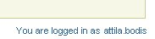
The greeting must be of the form “You are logged in as <username>.” It must be displayed in the OraInlineInfoText BLAF CSS style defined as follows:
.OraInlineInfoText {
font-family: Arial, Helvetica, Geneva, sans-serif;
color: #336699;
font-size: 8pt
}

Data Binding
The username displayed in the greeting must be the currently logged-in user’s single sign-on (SSO) username. Each application is responsible for retrieving this value dynamically.

Accessibility
No issues.

Globalization
The greeting text must be translated. Note that since the greeting is parameterized, the text submitted for translation should be of the form “You are logged in as {0}”; this ensures proper translation in all languages.

Implementation
Pages built using UIX should use the <userInfo> named child of the <pageLayout> element to render the greeting:
<!-- UIX 2.1.9 -->
<pageLayout>
...
<userInfo>
<stackLayout>
<contents>
<styledText styleClass="OraInlineInfoText"
data:text="..."/>
<spacer width="1" height="6"/>
</contents>
</stackLayout>
</userInfo>
...
</pageLayout>

Note the use of <stackLayout> and <spacer> in the above code snippet; the spacer ensures that any content containers rendered under the greeting are aligned with the page title; this is purely for aesthetic reasons.

Footer
All Collaboration Suite applications must support the following page footer:
The footer consists of a set of navigation links and a copyright statement. There is still issue with the footer link generation for the application items in the in-context image-styled application switcher area. The request is submitted to the CABO team for the support in the later UIX release.

Navigation Links
The page footer navigation links essentially duplicate the first-level tabs and the global buttons. The order of the navigation links is significant: links based on first-level tabs first (in the same order as the corresponding tabs), followed by links based on global buttons (in the same order as the corresponding buttons). Links must be separated using pipe (“|”) characters.
If a tab or global button is not rendered for any reason, the corresponding navigation link must not be rendered either.

Data Binding
The URLs for the navigation links must match the URLs bound to the tabs or global buttons they are based on.

Accessibility
The navigation links must be keyboard-navigable.

Globalization
The text of the navigation links must match the text of the corresponding tabs and buttons, and as such must be translated.

Implementation
UIX automatically implements the footer navigation links as long as <pageLayout> was used to create the page. No additional work is necessary.

Copyright Statement
Each application must display the following copyright statement in the bottom left corner of the page, flush with the bottom and left margins: “Copyright © 2002, 2003 Oracle Corporation. All rights reserved.”
The copyright statement must be displayed using the OraCopyright BLAF CSS style, defined as follows:
.OraCopyright {
font-family: Arial, Helvetica, Geneva, sans-serif;
color: #000000;
font-size: 8pt;
text-align: left
}

Data Binding
The copyright statement is static text; no data binding required.

Accessibility
No issues.

Globalization
The copyright statement must be translated.

Implementation
UIX implementations should use the <copyright> named child of the <pageLayout> element (which automatically selects the correct CSS style):
<!-- UIX 2.1.9 -->
<pageLayout>
...
<copyright>
<stackLayout>
<contents>
<spacer width="1" height="1"/>
<text data:text="..."/>
</contents>
</stackLayout>
</copyright>
...
</pageLayout>

Adding a <spacer> above the copyright statement reduces visual clutter.

Preferences
Each application will have its own preference page, which will be accessible by clicking the “Preference” global button from the application page. The URL of “Preference” global button will be dynamically bound depends on current application page. However, all application preference pages will have to link to a “General Preferences” page, which will contain common preferences like password, and time zone.
All Collaboration Suite application preference pages must support the following page layout:
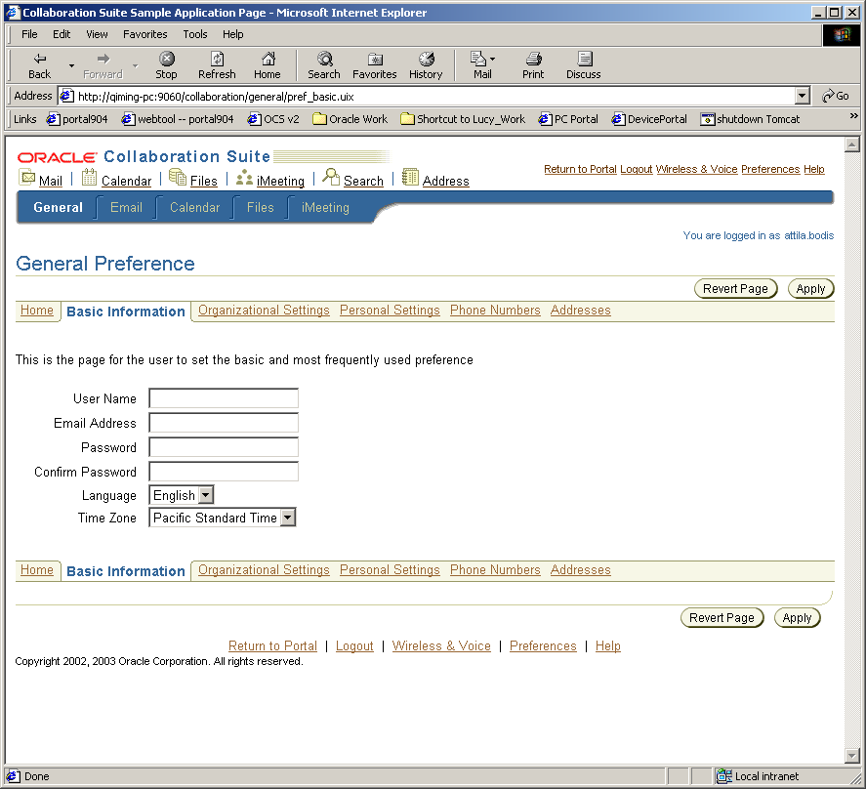
Header
Footer
Fourth-level Tabs
Each page is made up of a standard page header, the application-specific preference page body, and a standard page footer. The fourth-level tabs are for categorizing the preference settings within one application.
The action flow and semantics for the general preference page and the application preference pages are :
- From any application, the user can click “Preferences” and navigate to the Preferences Home page. Clicking on this link should pass a return-to URL so when the user is done with preferences they can be returned where they came from.
- The user can click any of the second-level tabs to navigate to general, mail, calendar, files, etc. preferences.
- On any preference page, clicking “Revert Page” should revert the information within the page. (Cannot revert back information after hitting "Apply")
- On any preference page, clicking “Apply” should submit changes *for that application only* (changes have been made across the 4th level tabs). Once users click "Apply", it should directed back to the main page (General- Home page) with a comfirmation box showing on top on Gerenal-Home page to state changes has been make. (If there is an error, the same preference page should be redisplayed with an error message; this is controlled by the application internally).
- Clicking “Ok” on the Preferences Home page must take the user back to the page they came from when they clicked Preferences in the first place.

Header
All Collaboration Suite preference pages must support the following page header:
Logo & Application Switcher
Global
Buttons

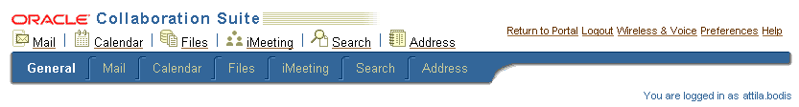
2nd-Level Tabs

The page header is made up of a logo, a global button bar, application switcher, and second-level tabs.
The header style can be configured into medium and regular branding styles. For the medium branding style, the global buttons will be rendered in links only. And for the regular branding style, the global buttons can be rendered in both icon and text style.
The application switcher can be configured into 3 different styles : icon and text, text only, or icon only.
Following are the 6 different header styles :
(1) Regular branding style + icon and text application switcher
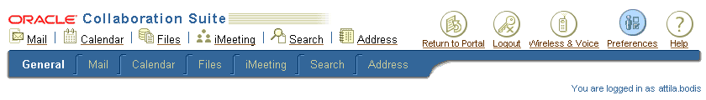
(2) Regular branding style + icon only application switcher

(3) Regular branding style + text only application switcher
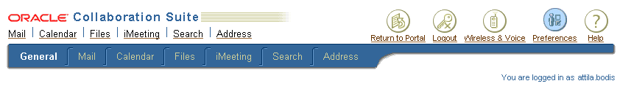
(4) Medium branding style + icon and text application switcher
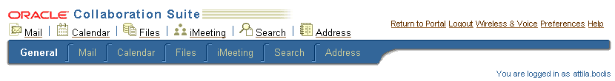
(5) Medium branding style + icon only application switcher
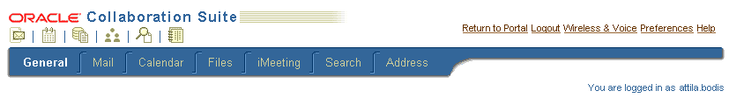
(6) Medium branding style + text only application switcher
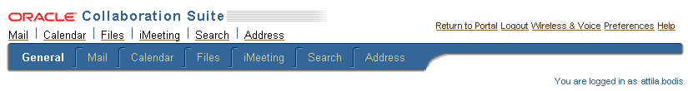

Logo
The logo is the same as described in section 4.5.2.1.1.

Global Buttons
As mention in above section that the render style can be configured to 2 different styles : regular branding style (icon and text), or medium branding style (text only).


The global buttons are the same as the ones on each application page, specified in section . The only difference is the Preference button should be highlighted to indicate the current page is a preference page.
The button images can be downloaded from Files Online at http://files.oraclecorp.com/content/MyWorkspaces/ST%20Functional%20Specs/OCSv2/Common%20Web%20UI/Images

Second-Level Tabs
All top-level application preference pages must display the following BLAF-compliant second-level tabs:
The order of the tabs is significant (established by the Collaboration Suite product management team): “General” preference tab, “Mail” preference tab, followed by “Calendar” preference tab, followed by “Files” preference tab, followed by “iMeeting” preference tab, followed by “Search” preference tab, followed by “Address” preference tab.
The second-level tabs should be generated using UIX; there are no static image files available.
Each application is responsible for ensuring that the corresponding second-level tab is selected (e.g. the Files application must ensure that the Files Preference tab is selected in all Files application preference pages).
Each application is responsible for ensuring that only tabs corresponding to configured applications are rendered. For example, if Calendar is not installed, all other applications must ensure that the Calendar Preference tab is not rendered on their application preference pages.
Clicking on any second-level tab will take the user to the corresponding application preference.

Data Binding
The URLs for each second-level tab must be retrieved from the global registry if available; any application that has not been configured (and is therefore not found in the global registry) must not have its corresponding second-level tab rendered.

Accessibility
All second-level tabs must have associated ALT texts for screen readers. The tab bar must be keyboard-navigable.

Globalization
All second-level tab text (and associated ALT text) must be translated.

Implementation
To be completed.

Fourth-level property Tabs
If the application only have one page of preference, the side navigation bar is not necessary.
If the application’s preference is sorted into several categories, which are displayed on several pages, fourth-level tabs should be used to identify and link to each category.
The fourth-level property tabs should be generated using UIX image generation; there are no static image files available.
Each application is responsible for ensuring that the fourth-level property tab is selected when the corresponding preference page is displayed.

Data Binding
The URLs for each side navigation link is application specific.

Accessibility
All side navigation links must have associated ALT texts for screen readers. The fourth-level property tabs must be keyboard-navigable.

Globalization
All side navigation link text (and associated ALT text) must be translated.

Implementation
Pages built using UIX should implement the global header using the <subTabBar> named child of the <stackLayout> element:
<!-- UIX 2.1.9 -->
<stackLayout>
...
<subTabBar data:selectedIndex="... " >
<contents>
<link data:text="..." data:destination="..." />
</contents>
</ subTabBar >
...
</stackLayout>

Footer
The footer for preferences pages is essentially the same as the footer described for application pages in section 4.5.2.2.

Common Preference
Common preference page is for setting the common preference attributes, which are shared across multiple applications. For example, Language and Time Zone is used by both Wireless and Calendar. Common Preference page is the central place for those attributes. The application reference page should not provide the setting for those attributes. However, all application preference pages will have to link to a “General Preferences” page, which will contain common preferences.

Welcome Page
The welcome page is the entry point to the Oracle Collaboration Suite. This page gives an introduction of the OCS product and also gives the highlight points linking to the detail information page. The most important function of the welcome page is to allow the user to login to the OCS product. This page is also designed as a customized SSO login page.
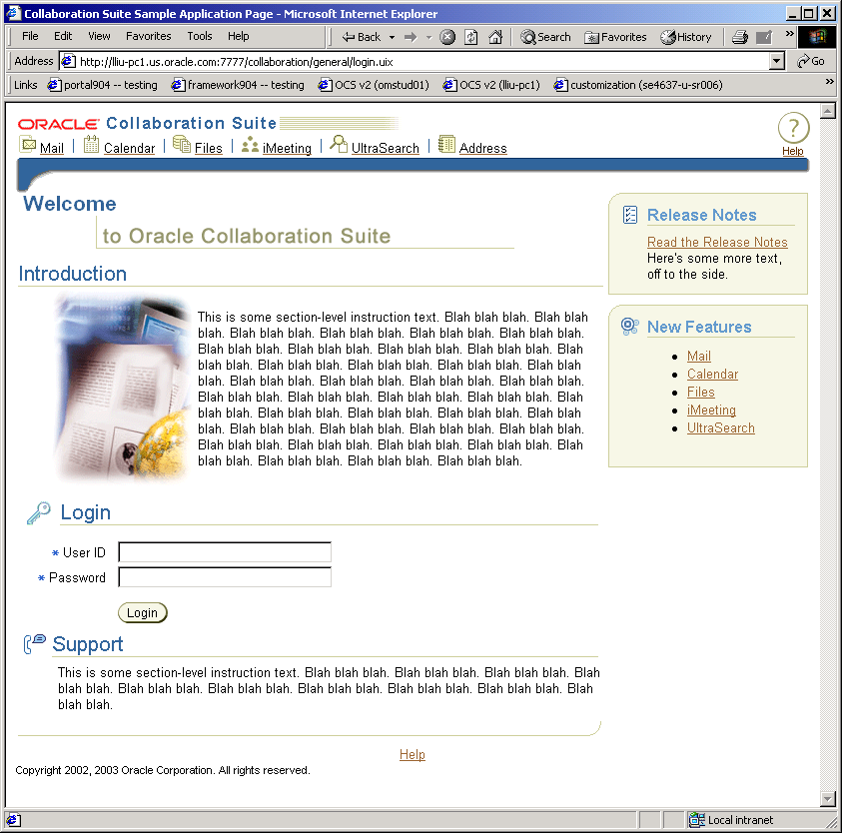
Welcome Text
Introduction
Login
Highlights
Support

Welcome Text
Welcome is the greeting and product name area

Introduction
The introduction gives an overview of the product and may also briefly cover each application.

Login
The login area is for the user to type in user name and password to login to OCS web site. The user identity is authenticated through Single Sign On server. All Collaboration Suite users will be created by system administrator, so no self-registration will be provided in the login page. “Forget Password” may not be provided. This feature will need support from OiD, so we leave this as an open issue. Multi-subscriber support will not be supported out-of-box. Regarding the feature of customized look-and-feel for different domain of users will not be supported in v2.

Highlights
This area can include multiple content containers to display the latest news of the OCS product. Since the space is limited, the large amount of content should be placed in a separate page linking from this area.
This area should be customizable, so that the customers can plug in their own highlight information. A link (or a viewlet) to the Collaboration Suite Quick Tour will be provided here.

Support
This area presents the support information, such as link to the FAQ pages, or the support contacts.
The support area should be customizable, so that the customers can replace the default information with their own IT support contacts.

Open Issues in Welcome Page ( aka Customized SSO Login Page ) :
  - Forget Password support :
    - This feature will need support from OiD.
  - Multi-subscriber support :
    - Instead of overloading the functionalities in the login page, this feature should be configured in the process of installation or post-installation.
  - Language selection for the welcome page
    - This feature will need further discussion : Whether the language used in the welcome page should be decided by the browser or by the user’s selection ?
  - Customized look-and-feel support :
    - This feature will require support from all applications which is not feasible in v2 timeframe. And the selection will not be in the Login page, it will be one of the customization item in the individual application portlet. (A suggested solution is provided in the next item list.)
    - Currently, iMeeting has this feature for users to customize the look-and-feel of detail application page. This feature could be achieved in the portlet page. In portlet home page, a selection for “user’s domain” can be displayed either in the iMeeting portlet or in the detail customization page of iMeeting portlet. When the user navigates into the detail iMeeting application page by clicking on the application name link, the look-and-feel of the application page should be decided by the user’s domain selection in the portlet page.

Help

Application Context-Sensitive Help Page
The application help page is invoked by clicking on the global help button when the application is currently used. For example, if the user is reading emails, clicking on the help button should pops up the help page for Email application.
The on-line help page is preferred to be context-sensitive. In another world, the content displayed on the popup window should explain the function of the current Email application page. However, if context-sensitive help is not implemented, directing to the top help page of the application is also acceptable.
The suggested on-line help window is illustrated with the following image.
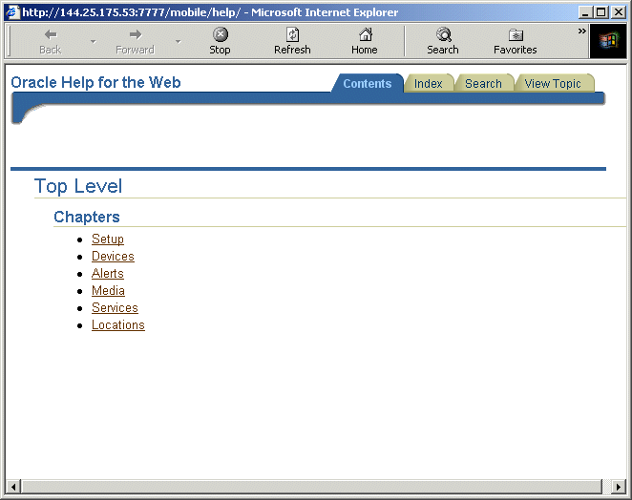

The help window should be a non-modal popup window, which allows the user to continue the operation while referring to the on-line help pages.
The window size should be 650 at width and 450 at height.
The window should not have menu bar, location bar, status bar, and directory bar.
The page may have tabs for viewing Contents, Index, Search, and Topic.
- Content – list the table of contents for browsing across chapters (Must-to-have)
- Index – list the index of key words for quick referencing (Optional)
- Search – provide search capability for locating interesting contents (Optional)
- Topic – display the selected topic based on the current working application page (Optional)

Data Binding
The URLs on the help window are application specific. Each application is responsible for setting those URLs to the correct help pages within the application.

Accessibility
All tabs and images must have associated ALT texts for screen readers. The tab bar must be keyboard-navigable.

Globalization
All help content and image-associated ALT text must be translated.

Implementation
Help implemented with Oracle Help for Web (OHW) is automatically compliant with the requirements. The help content should be written in normal html and packaged into a helpset jar file with RoboHelp, or Oracle Help Authoring Tool. When invoking the help window from UIX page, the following code should be used.
<!-- UIX 2.1.9 -->
<pageLayout>
...
<globalButtonBar>
<contents>
...
<globalButton source="/images/help_page.gif"
data:text="help@labelBundle"
data:destination="oneTopic@ui:helpTopics"/>
</contents>
</globalButtonBar>
...
</pageLayout>

If the application help system is not implemented with OHW, the following html code should be in place for the global help button.
<a href="javascript:(new Function('a', 'b', 'c', 'd', 'openWindow(a, b, c, d)'))(top, 'http://hostname:port/application/help/','helpWindow', {width:650, height:450, menubar:0, location:0, status:0, directories:0});"><img src="/application/cabo/images/cache/gb-help_ena.gif" alt="Help" border="0" width="32" height="32"></a>

Portal Home Help Page
The screenshot below illustrates the help page for portal home.
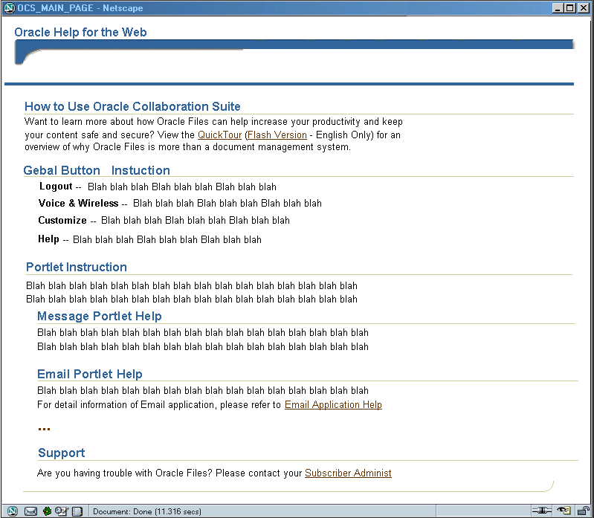
General Info
Global Button Help
Portlet Help
Support Info

General Information
The top part of the help page describes the general help information for Oracle Collaboration Suite.

Global Button Help
For each global button on the portal home page, the functionality should be described in details.

Portlet Help
The overview of each portlet should be provided under the portlet sub header. If the portlet corresponds to an application, such as Email, a clickable link should be included for viewing the application on-line help pages.

Support Information
Provide the support contacts in this area with a clear and straightforward presentation.

Data Binding
The portlet help section on the help page should be dynamically determined by the existence of the portlets on the portal home page, which depends on the application installation status.
The support information should be customizable by the customer to replace the default with the real contacts.

Accessibility
All images must have associated ALT texts for screen readers.

Globalization
All help content and image-associated ALT text must be translated.

Portlet-Level Help
The details of how to use a portlet should be provided at the portlet level. The user can access the portlet-level help by clicking on the question mark of the portlet.

Welcome Page Help
The help page for the welcome page is designed as follow.
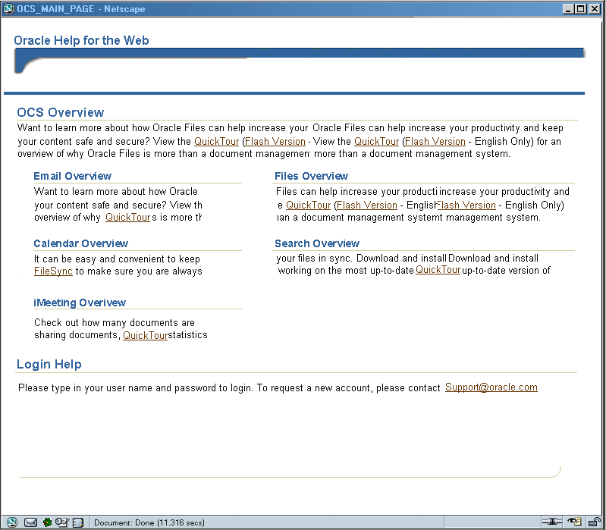

This help page includes OCS overview information, along with the brief introduction of each application installed in the suite.

The login help explains how to log in the suite. The new account request email link can also be included here.

Data Binding
The application introduction section on the help page should be dynamically determined the application installation status.
The support information should be customizable by the customer to replace the default with the real contacts.

Accessibility
All images must have associated ALT texts for screen readers.

Globalization
All help content and image-associated ALT text must be translated.

Portal Home Page
Portal Home Page is the default home page for the registered Collaboration Suite user.
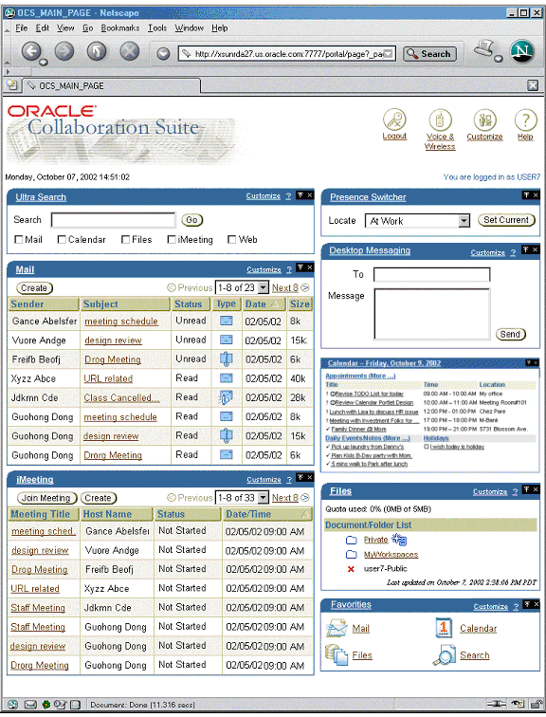

Header
Logo
Global
Buttons

Date & Time
Greeting

The page header is made up of a logo, a global button bar, a date time prompt, and a greeting. The logo and global buttons are constructed as separate portlets in the banner area of a portal page:
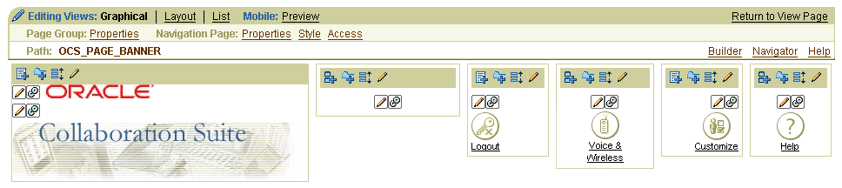
The date time and the greeting are also portlets in a portal page.

Logo
The logo is the same as discussed in section 4.5.2.1.1.

Implementation
This logo portlet will be created in portal by including two images in the left-upper corner item region: a small corporate branding logo image and a large product logo image.

Global Buttons
The global button bar is similar to the one discussed in section :

The order of the buttons is significant (per BLAF): Logout button, followed by application-specific button(s), followed by Customize button, followed by help. Currently, the application-specific button only has “Voice & Wireless” button.
Semantics are as follows:
- Clicking “Logout” logs the user out of single sign-on (SSO). This button is always present.
- Clicking “Voice & Wireless” takes the user to the voice & wireless setup wizard. The “Voice & Wireless” button must be hidden if the iAS Wireless server is not configured.
- Clicking “Customize” takes the user to the portal customization page. It allows user to customize the portal page by hiding/showing, re-arranging or adding/removing portlets. This button is always present.
- Clicking “Help” to popup a window of oracle on-line help page regarding the Portal Home Page. This button is always present.

Data Binding
The “Wireless & Voice” URL must be retrieved from the global registry if present; otherwise the button must not be rendered.
The “Customize” URL is controlled by portal page framework.
The “Help” URL is generated based on browser’s locale. (??? need to get confirmed???)

Accessibility
Each global button image must have associated ALT text in order to be properly processed by screen readers. The global button bar must be keyboard-navigable.

Globalization
All global button labels and all associated ALT texts must be translated.

Implementation
The global buttons contain 2 built-in navigation items and 2 portlets. The portlets implemented in JSP using JPDK and UIX bean to render global buttons and links. All the image buttons are rendered as “image above link” style.
Built-in navigation items:
- Logout button: is a portal built-in navigation item with type of Login/Logout Link
- Customize button: is a portal built-in navigation item with type of Portal Smart Link –Customize
Portlets:
- Voice & Wireless button: This portlet is written in JSP that use JPDK and GlobalButtonBean provided by CABO to render the global buttons “Voice & Wireless”.
- Help button: This portlet is also written in JSP that use JPDK and GlobaleButtonBean to render a global button “Help”. The link is generated based on the current browser’s locale setting.

Date/Time

Data Binding
This Date/Time portlet will retrieve server’s current date time information.

Accessibility
Not clickable.

Globalization
The date time information will be presented in the localized format based on the current browser’s locale setting.

Implementation
The portlet will be implemented in JSP.

Greeting
The greeting must be of the form “You are logged in as <username>.” It must be displayed in the OraInlineInfoText BLAF CSS style defined as follows:
.OraInlineInfoText {
font-family: Arial, Helvetica, Geneva, sans-serif;
color: #336699;
font-size: 8pt
}

Data Binding
The username displayed in the greeting must be the currently logged-in user’s single sign-on (SSO) username. Each application is responsible for retrieving this value dynamically.

Accessibility
Not clickable.

Globalization
The greeting text must be translated. Note that since the greeting is parameterized, the text submitted for translation should be of the form “You are logged in as {0}”; this ensures proper translation in all languages.

Implementation
The portlet will be implemented in JSP.

Portlets
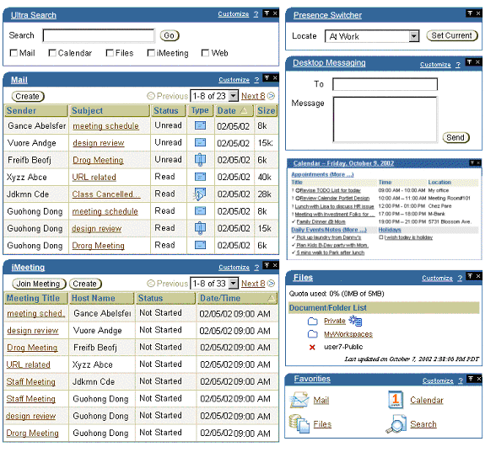

There’re total 8 portlets: Presence Switcher, Ultra Search, Mail, iMeeting, Desktop Messaging, Calendar, Files, and Favorites.

Common Portlet Features

Clickable Title
All portlets should provide a clickable portlet name linking to the corresponding application page if the URL is configured, otherwise the name will not be clickable. This can be configured in provider.xml by setting showDetails to true and specifying the page name of showDetailsPage.
Following is the example to configure a clickable name link in provider.xml:
<portlet class="oracle.portal.provider.v2.DefaultPortletDefinition">
<id>1</id>
<name>DesktopMessaging</name>
<title> Desktop Messaging </title>
...
<showDetails>true</showDetails>
<renderer class="oracle.portal.provider.v2.render.RenderManager">
...
<showDetailsPage>/portlets/viewMessageLog.jsp</showDetailsPage>
...
</renderer>
</portlet>

Customize Link
All portlets should provide a portlet-level customize link shows in the portlet title area which will take user to the detail customize page if there’s any. This can be configured in the provider.xml by setting showEdit to true and specifying the page name of editPage.
Following is the example to configure a customize link in provider.xml:
<portlet class="oracle.portal.provider.v2.DefaultPortletDefinition">
<id>1</id>
<name>DesktopMessaging</name>
<title> Desktop Messaging </title>
...
<showEdit>true</showEdit>
<renderer class="oracle.portal.provider.v2.render.RenderManager">
...
<editPage>/portlets/customizeMessageView.jsp</editPage>
...
</renderer>
</portlet>

Help Link
All portlets should provide a portlet-level help link showing as a question mark link in the portlet title area which will popup a separate help window containing the help for the portlet. This also can be configured in provider.xml by setting showHelp to true and specifying the page name of helpPage.
Following is the example to configure a question mark help link in provider.xml:
<portlet class="oracle.portal.provider.v2.DefaultPortletDefinition">
<id>1</id>
<name>DesktopMessaging</name>
<title> Desktop Messaging </title>
...
<hasHelp>true</hasHelp>
<renderer class="oracle.portal.provider.v2.render.RenderManager">
...
<helpPage>/portlets/desktopMessagingHelp.jsp</helpPage>
...
</renderer>
</portlet>

Presence Switcher Portlet
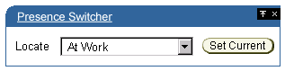
Semantics for Presence Switcher are as follows:
- The Presence Switcher is a portlet that contains a list of presences user can switch to present the user’s current status.
- To switch presence, user can choose one defined presences from the drop-down list and click “Set Current” button to switch.
- User can click on the clickable name link to go to the detail page to add more presence or change the settings of presences.
- If there’s no presence for this user, a message “Currently, no presence is available. Please click on the Presence Switcher title link to create new presences.” will be prompt in the portlet. (This message needs to be translated.)
- If there’s not presence available for the user and the name link is not configured. This portlet will display “The service is not available.” message. (This message need to be translated.)
- The UI design for the detail pages (including application detail, customize & help) will be addressed later. We need to gather more information and requirements about this portlet.

Data Binding
The selection of presences is retrieved from the repository.

Accessibility
The items must be keyboard-navigable.

Globalization
All labels need to be translated

Implementation
The portlet will be implemented in JSP using JPDK, wireless midtier APIs and CABO.

Search
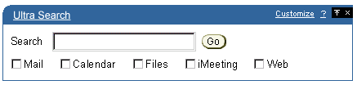
Semantics for Search portlet are as follows:
- User can type in the keyword and check the checkbox(es) for searched category to search the keyword in the selected categories.
- The name link in the title area will be clickable if the detail page is configured.
- The UI design for the detail pages (including application detail, customize & help) will be addressed later. We need to gather more information and requirements about this portlet.

Data Binding
The links to the detail page, edit page and help page are retrieved from the portlet provider configuration settings. If those links are not configured, the “Customize” and “?” links will not show up and the title name will not be clickable.

Accessibility
The “Go” button must have an associated ALT text for screen readers. The items must be keyboard-navigable.

Globalization
All labels need to be translated

Implementation
The portlet will be implemented in JSP using JPDK and CABO for image button rendering.

Favorites
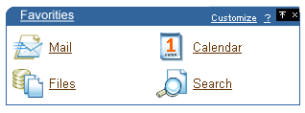
Semantics for Favorites portlet are as follows:
- User can click on the links that included in this portlet to navigate to the corresponding application page.
- User can click on the customize link to add or delete favorite links.
- If there’s no link in this portlet, a message “Currently, you don’t have any favorite links. Please click on the Customize link on the portlet tile to add more links”. (This message needs to be translated.)
- The UI design for the detail pages (including application detail, customize & help) will be addressed later. We need to gather more information and requirements about this portlet.

Data Binding
The links to the detail page, edit page and help page are retrieved from the portlet provider configuration settings. If those links are not configured, the “Customize” and “?” links will not show up and the title name will not be clickable.

Accessibility
All image buttons must have an associated ALT text for screen readers. The items must be keyboard-navigable.

Globalization
All labels need to be translated

Implementation
The portlet will be implemented in JSP.

Desktop Messaging
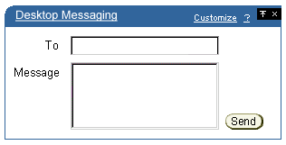
Semantics for Desktop Messaging are as following:
- User can send SMS to a phone number or email address. The limitation of one short message is about 140 bytes (~160 single-byte characters or ~70 multi-byte characters). If the length of the message is over this limitation, the message body will be split into multiple chunks and send out as multiple messages.
- This portlet will not verify if the short messaging address is valid or not. If the delivery is failed, no error will be prompt. The user can type in any format of phone number such as : +1 650 123 4567, or 1 (650) 123 4567, or 1-650-123-4567 … but all the non-numeric digits will be stripped out.
- User can select the recipient from personal address book.
- Clicking on the “Desktop Messaging” link, user can specify/change the return-to SMS address. This field should be pre-populated with the sender’s latest SMS address picked up from Presence Server.

Data Binding
The “To” input field is for user to type in the short messaging address which is a phone number. The limitation for this field is 0~20.
The “Message” input box is for user to type in the content of short message. The limitation for the “Message” input box is 0~256.

Accessibility
The “Send” button must have an associated ALT text for screen readers. The items must be keyboard-navigable.

Globalization
All labels in this portlet need to be translated.

Implementation
The portlet will be implemented in JSP using JPDK and CABO technology stack.

Mail
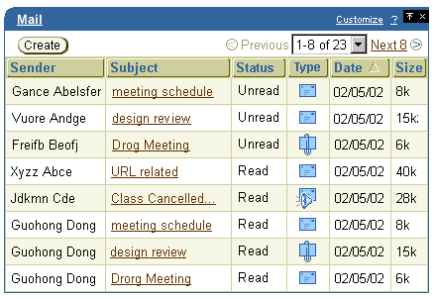
The semantics for Mail portlet will be provided by Mail team.
Above UI is just a suggested mockup screen from UI lab team.

Data Binding
N/a

Accessibility
All image buttons must have an associated ALT text for screen readers. The items must be keyboard-navigable.

Globalization
All labels need to be translated.

Implementation
The portlet will be implemented in JSP using JPDK.

Calendar

(from Calendar Portlet Design Doc)
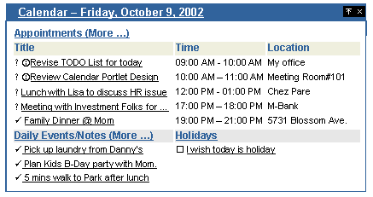
Goal : Come up with similar or bit more functionalities than current Oracle Collaboration Suite Calendar Portlet in V1, but using entirely new backend data gathering mechanism. Events status icons and imeeting icon for applied events.
Changes in V2 are:
- Calendar link on top will now contain current viewing date information
- Event has URL that leads to a particular event in Calendar Web Client for full edit activity
- When coming back from Calendar Web Client, update content will be shown in Portlet
- There is “More…” link available if more than X number of entries are available.
- Marconi.config – See following table for complete parameter list
KEY | Default value | Description
Calendar.maxapptsperday | 10 | Maximum displayable appointments per day  N >= 1 (if N < 1, N will be set to 1)
Calendar.maxdeventsperday | 5 | Maximum displayable day events per day  N >= 1 (if N < 1, N will be set to 1)
Calendar.maxdnotesperday | 5 | Maximum displayable daily notes per day  N >= 1 (if N < 1, N will be set to 1)
Calendar.maxtholidayperday | 5 | Maximum displayable tasks per day  N >= 1 (if N < 1, N will be set to 1)
- To provide functionalities of Calendar Portlet, the Oracle Calendar Web Services product module will be used to feed the required calendaring data. Using the Java Calendarlet classes and Calendar Application Server, within Oracle HTTP Server (OHS), all the information required to generate the calendaring portion of the Calendar Portlet is accessible. The Java Calendarlet hides all the details of using SOAP to access the Calendar data. All that is required is the URL of the host where the Calendar Web Services component is installed, which gets read during Portlet services initialization – Portlet provider initialization.
(Please refer to Calendar Portlet Design Doc for more detail)

Data Binding
N/a

Accessibility
All image buttons must have an associated ALT text for screen readers. The items must be keyboard-navigable.

Globalization
All labels need to be translated.

Implementation
The portlet will be implemented in JSP using JPDK.

Files
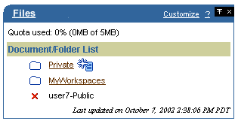
The semantics for Files portlet will be provided by Files project team.
Above UI is just a suggested mockup screen from UI lab team.

Data Binding
N/a

Accessibility
All image buttons must have an associated ALT text for screen readers. The items must be keyboard-navigable.

Globalization
All labels need to be translated.

Implementation
The portlet will be implemented in JSP using JPDK.

iMeeting
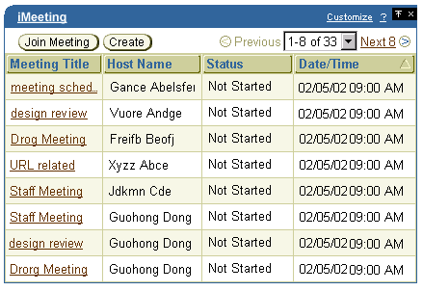
The semantics for iMeeting portlet will be provided by iMeeting project team.
Above UI is just a suggested mockup screen from UI lab team.

Data Binding
N/a

Accessibility
All image buttons must have an associated ALT text for screen readers. The items must be keyboard-navigable.

Globalization
All labels need to be translated.

Implementation
The portlet will be implemented in JSP using JPDK.

APIs/Classes
To be completed.

Configuration Files
N/A.

Other User Interfaces
N/A.

Installation and First Use
Installation and configuration of the Collaboration Suite Release 2 Common Web UI is covered by the OCS Configuration Assistant functional specification document (see project #8160).

Dependencies and Effects

Software
To be completed.

User Documentation
To be completed.

Internal Documentation
N/A.

Compatibility & Migration
In Collaboration Suite v2, a totally new portal home page and a set of new portlets will be constructed. Therefore, there’s no migration issue for the web UI.
- References
- Calendar Portlet Design Document (Web Technologies Team) http://files.oraclecorp.com/content/MyWorkspaces/ST Functional Specs/OCSv2/Calendar/8089 Calendar Web Services/ARRA_DES_CalendarPortlet.doc
- Oracle Collaboration Suite Product Requirement Document (PRD) http://files.oraclecorp.com/content/MyWorkspaces/Collab Suite Wireless/PRD/PRD_Common_WebUI_111702.doc
Glossary
N/A.
- Open Issues
The following issues have been identified:
Issue | Owner | Status | Notes
Tabs vs. Switcher | richard.wright | OPEN | iMeeting cannot implement the common tab bar due to navigation issues. Files is suggesting an application switcher element instead.  AI: Richard to explore alternative top-level navigation UI design (e.g. icon bar).
Directory | attila.bodis | OPEN | Should there be a top-level directory UI for Aria-style lookups in OID?
Personal Address Book | attila.bodis | OPEN | Currently, the Personal Address Book is a subtab of Webmail. Should it be either a subtab of a top-level Directory application (see above), or a global button? What about a Personal Address Book LOV pop-up?
Consolidated Preferences | attila.bodis | OPEN | Should teams redo their preferences UI by factoring out common user preferences (password, timezone, etc.)?
Consolidated Administration | attila.bodis | OPEN | Should teams redo their administration UI by factoring out common tasks and moving everything behind a common “Administration” tab?
SSO Login Page | attila.bodis | OPEN | What should the common SSO login page contain?
Sticky Login | attila.bodis | OPEN | Should SSO support sticky logins by default? How should applications take advantage of it?
Application Context | attila.bodis | OPEN | To what extent should applications maintain context within the suite as the user navigates among apps via the web UI?
Portlets | attila.bodis | OPEN | What functionality should be supported in each of the application portlets?
Lightweight Portal UI | attila.bodis | OPEN | Should we develop lightweight portlets for common tasks like viewing email, scheduling an appointment, etc?

- Decisions
To be completed.
- Index
N/A.

